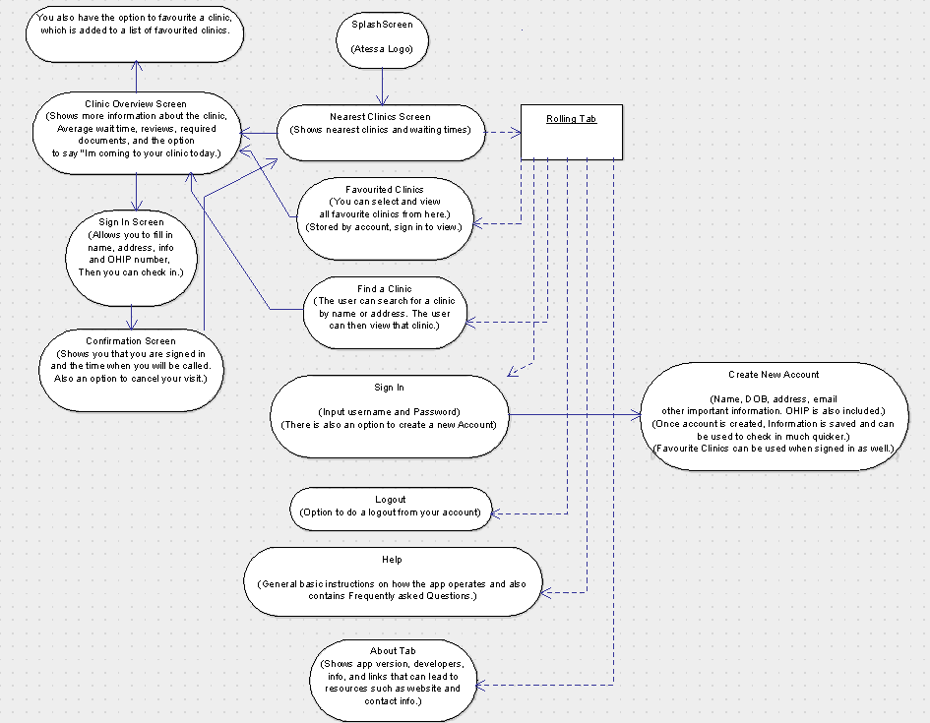

Atessa App Activity Flow Diagram

Dariusz K, Anthony P, Winston (something I don’t remember)

Milestone 2 – October 2nd, 2018